Exercise 1

1. What is Computer?

2. What are the essential parts of computer?

3. Who are the notable inventors of the hardware and software?

-Cite at least (5) Software Developers and (5) Hardware Developers.

4. Cite your reference/s (APA/IEEE)

ANSWER;

1. A computer is a machine that can store, process, and manipulate data/information.

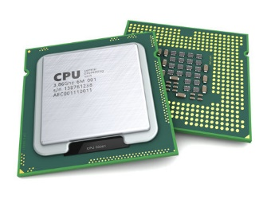2. The essential parts of computer are;

- CPU(Central Processing Unit) - it is the primary control center of the computer, it manages the different hardware and software components of the computer.

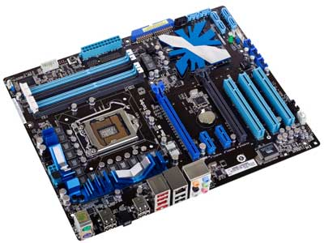

- Mother Board - it acts as the central electrical circuit of the computer. It is responsible for distributing power, and delivering information and instructions across the computer system.

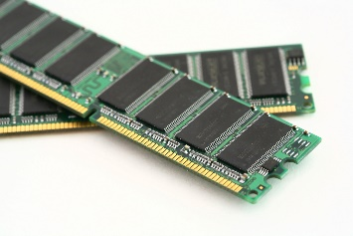

- RAM(Random Access Memory) - is a memory space that houses temporary data, processes, information, and commands.



- Power Supply - it supplies the CPU power to function the whole computer system.

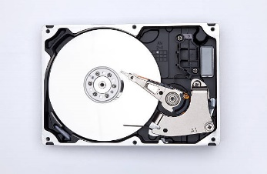 - Hard Drive - is a storage where files, programs, and information can be stored.

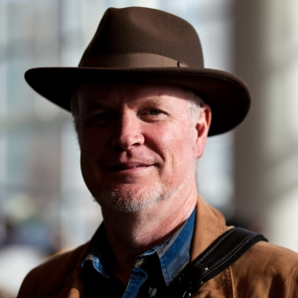3. SOFTWARE DEVELOPERS;

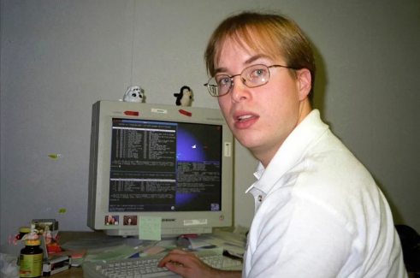**Tim Bray**   
 -One of the   
creators of XML.

**Paul Buchheit**- Creator Gmail.

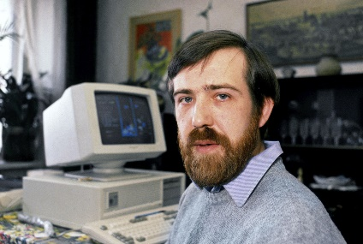

**Alexey Pazhitnov**-Creator of Tetris

HARDWARE DEVELOPERS;

4. Citation (Citation Generator is used);

- (1) Freiberger, P. A. , Pottenger, . William Morton , Swaine, . Michael R. and Hemmendinger, . David (2024, July 4). computer. Encyclopedia Britannica. <https://www.britannica.com/technology/computer>

- (2) What is Computer | Types and Advantages - javatpoint. (n.d.). www.javatpoint.com. <https://www.javatpoint.com/what-is-computer>

- (3) 14 Basic Components of A Computer | Career Development - indeed. (2023, August 28). <https://in.indeed.com/career-advice/career-development/components-of-a-computer>

- (4) Vedantu. (n.d.). Monitor: Importance and uses of monitors. VEDANTU. <https://www.vedantu.com/computer-science/monitor>

CITATION FOR ITEM NO. 3

- (1) Tim Bray (@tim-bray) / Passes. (n.d.). Passes. <https://www.passes.com/wiki/tim-bray>

- (2) *Paul Buchheit - creator of Gmail, Adsense and FriendFeed*. (n.d.). CrazyEngineers. <https://www.crazyengineers.com/founders-circuit/mr-paul-buchheit-gmail-adsense>

- (3) Nutt, C. (2023, December 27). *Alexey Pajitnov - _Tetris_: Past, Present, future*. <https://www.gamedeveloper.com/business/alexey-pajitnov---i-tetris-i-past-present-future>

- (2)

- (2)

- (2)